Sleeping Beauty (Briar Rose)
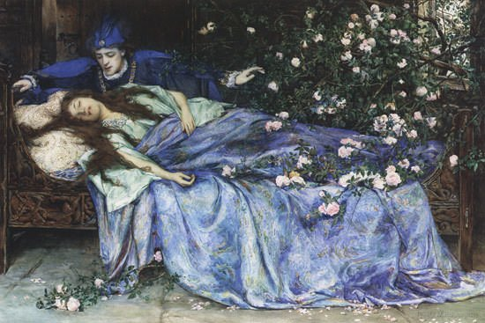
In olden times there lived a King and Queen, who lamented day by day that they had no children, and yet never a one was born. One day, as the Queen was bathing and thinking of her wishes, a Frog skipped out of the water, and said to her, "Your wish shall be fulfilled, — before a year passes you shall have a daughter."

As the Frog had said, so it happened, and a little girl was born who was so beautiful that the King almost lost his senses, but he ordered a great feast to be held, and invited to it not only his relatives, friends, and acquaintances, but also all the wise women who are kind and affectionate to children. There happened to be thirteen in his dominions, but, since he had only twelve golden plates out of which they could eat, one had to stop at home. The fete was celebrated with all the magnificence possible, and, as soon as it was over, the wise women presented the infant with their wonderful gifts; one with virtue, another with beauty, a third with riches, and so on, so that the child had everything that is to be desired in the world. Just as eleven had given their gifts, the thirteenth old lady stepped in suddenly. She was in a tremendous passion because she had not been invited, and, without greeting or looking at anyone, she exclaimed loudly, "The Princess shall prick herself with a spindle on her fifteenth birthday and die!" and without a word further she turned her back and left the hall. All were terrified, but the twelfth fairy, who had not yet given her wish, then stepped up, but because she could not take away the evil wish, but only soften it, she said, "She shall not die, but shall fall into a sleep of a hundred years' duration."

The King, who naturally wished to protect his child from this misfortune, issued a decree commanding that every spindle in the kingdom should be burnt. Meanwhile, all the gifts of the wise women were fulfilled, and the maiden became so beautiful, gentle, virtuous, and clever, that everyone who saw her fell in love with her. It happened on the day when she was just fifteen years old that the Queen and the King were not at home, and so she was left alone in the castle. The maiden looked about in every place, going through all the rooms and chambers just as she pleased until she came at last to an old tower. Up the narrow winding staircase, she tripped until she arrived at a door, in the lock of which was a rusty key. This she turned, and the door sprang open, and there in the little room sat an old woman with a spindle, spinning flax. "Good-day, my good old lady," said the Princess, "what are you doing here?"

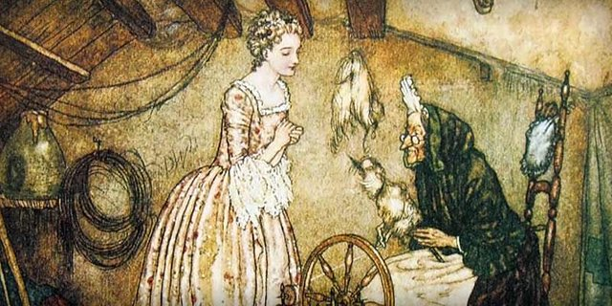
"I am spinning," said the old woman, nodding her head.

"What thing is that which twists round so merrily?" inquired the maiden, and she took the spindle to try her hand at spinning. Scarcely had she done so when the prophecy was fulfilled, for she pricked her finger; and at the very same moment, she fell back upon a bed which stood near in a deep sleep. This sleep extended over the whole palace. The King and Queen, who had just come in, fell asleep in the hall, and all their courtiers with them — the horses in the stables, the doves upon the eaves, the flies upon the walls, and even the fire upon the hearth, all ceased to stir — the meat which was cooking ceased to frizzle, and the cook at the instant of pulling the hair of the kitchen-boy lost his hold and began to snore too. The wind also fell entirely, and not a leaf rustled on the trees around the castle.
Now around the palace, a thick hedge of briars began growing, which every year grew higher and higher, till the castle was quite hidden from view so that one could not even see the flag upon the tower. Then there went a legend through the land of the beautiful maiden Briar Rose, for so was the sleeping Princess named, and from time to time Princes came endeavoring to penetrate through the hedge to the castle; but it was not possible, for the thorns held them as if by hands, and the youths were unable to release themselves, and so perished miserably.

After the lapse of many years, there came another King's son into the country, and heard an old man tell the legend of the hedge of briars; how that behind it stood a castle where slept a wonderfully beauteous Princess called Briar Rose, who had slumbered nearly a hundred years, and with her the Queen and King and all their court. The old man further related what he had heard from his grandfather, that many Princes had come and tried to penetrate the hedge, and had died a miserable death. But the youth was not to be daunted, and, however much the old man tried to dissuade him, he would not listen, but cried out, "I fear not, I will see this hedge of briars!"

Just at that time came the last day of the hundred years when Briar Rose was to wake again. As the young Prince approached the hedge, the thorns turned to fine large flowers, which of their own accord made a way for him to pass through, and again closed up behind him. In the courtyard, he saw the horses and dogs lying fast asleep, and on the eaves were the doves with their heads beneath their wings. As soon as he went into the house, there were the flies asleep upon the wall, the cook still stood with his hands on the hair of the kitchen-boy, the maid at the board with the unplucked fowl in her hand. He went on, and in the hall he found the courtiers lying asleep, and above, by the throne, were the King and Queen. He went on further, and all was so quiet that he could hear himself breathe, and at last, he came to the tower and opened the door of the little room where slept, Briar Rose.

There she lay, looking so beautiful that he could not turn away his eyes, and he bent over her and kissed her. Just as he did so she opened her eyes, awoke, and greeted him with smiles. Then they went down together, and immediately the King and Queen awoke, and the whole court and all stared at each other wondrously. Now the horses in the stable got up and shook themselves, — the dogs wagged their tails, — the doves upon the eaves drew their heads from under their wings, looked around, and flew away, — the flies upon the walls began to crawl, the fire to burn brightly and to cook the meat, — the meat began again to frizzle, — the cook gave his lad a box upon the ear which made him call out, — and the maid began to pluck the fowl furiously. The whole palace was once more in motion as if nothing had occurred, for the hundred years' sleep had made no change in anyone.

By and by the wedding of the Prince with Briar Rose was celebrated with great splendor, and to the end of their lives they lived happily and content.
THE END

Post-Reading Task
After reading the story, please complete the following:

I. Vocabulary:
Please explain the meaning of the following words and expressions from the story:
Note: you can also use the online Cambridge dictionary at http://dictionary.cambridge.org/dictionary/american-english/
WORD | DESCRIPTION
lament (v)
sense (n)
feast (n)
dominion (n)
fete (n)
magnificence (n)
virtue (n)
passion (n)
exclaim (v)
prick (v)
spindle (n)
misfortune (n)
decree (n)
maiden (n)
flax (n)
twist (v)
inquire (v)
scarcely (adv)
prophecy (n)
eave (n)
hearth (n)
frizzle (v)
hedge (n)
briar (n)
legend (n)
endeavor (n)
penetrate (v)
perish (v)
slumber (v)
daunt (v)
dissuade (v)
fowl (n)
courtier (n)
throne (n)
wondrously (adv)
pluck (v)
motion (n)
splendor (n)
content (adj)
II. Questions about the story:
- Upon the birth of his beautiful daughter the King invited many guests, including ‘wise women’ (like fairy godmothers). a) What gifts did these women bring? b) What was the surprise nobody was expecting? _____________________________________________________________________________
_____________________________________________________________________________
_____________________________________________________________________________
- What prophecy was declared and by who?
_____________________________________________________________________________
_____________________________________________________________________________
- Did the foretold prophecy come true? How and when did it happen?
_____________________________________________________________________________
_____________________________________________________________________________
- Do you believe in prophecies? Why or why not?
_____________________________________________________________________________
_____________________________________________________________________________
- How long did the princess sleep?
_____________________________________________________________________________
- What happened while she was sleeping? (both within her and inside the castle)
_____________________________________________________________________________
_____________________________________________________________________________
_____________________________________________________________________________

III. Symbols:
A symbol is thing such as an object that is used to represent something else. It can also be used to represent an idea or message. For example, the blooming flower in Disney’s Mulan can represent a girl growing and becoming beautiful.

Now, what do you think the following objects could symbolize?

Object / Symbol | Symbolizes (represents)
12 golden plates
13th fairy
Object / Symbol | Symbolizes (represents)
spindle
briar
prince

IV. Metaphors:
A metaphor is a way of describing something by comparing it to something unlike it, but having similar qualities. For example, a candle can be a metaphor for hope or love.
Write down what you think the following metaphors could represent in today’s world.
Metaphor for…
spinning spindle
sleep
kiss
(from the prince)

