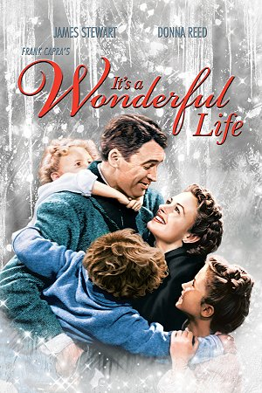
At the Movies – It’s a Wonderful Life
Title: It’s a Wonderful Life
Country: USA
Year: 1946
Motion Picture Rating: PG
Notable Actors: James Stewart
Synopsis: On the Christmas Eve of Bedford Falls, the guardian angel Clarence is assigned to convince the desperate George Bailey not to commit suicide. George is a good man that sacrificed his dreams and his youth on behalf of the citizens of his small town. He inherited the loan business of his father and he gave up traveling the world and joining University as scheduled. Later he resisted the proposals of the evil banker Mr. Potter, and never sold his business to protect the poor community of Bedford Falls and offer a means to afford to buy their own house. He married his beloved Mary Hatch Bailey and had four children with her and a tough life with his family. When his uncle Billy loses US$ 8,000.00, found and stolen by Mr. Potter, George decides to commit suicide, since he believes he worth more dead than alive. When Clarence sees that he is not able to persuade George to give up his intention, he decides to show the life in town if George had never existed. – Source IMDB

Background: The movie was inspired on a 1943 short story entitled The Greatest Gift written by Philip Van Doren Stern. You can read the story here (PDF). It is also worthwhile to note that It's a Wonderful Life was written and directed by the very gifted Frank Capra who directed another American classic also starring James Stewart, namely Mr Smith goes to Washington (1939).
BEFORE VIEWING...
Have a look at the following questions before you watch the movie. There are spaces provided for you to take notes. You can either pause the movie to take notes, or write them after viewing it. Just make sure that your note taking doesn't interrupt your careful watching.
PART 1 - Questions about the story
1) What themes are present in this movie? And how do they relate to today's world/society?
___________________________________________________________________________________________________________________________
___________________________________________________________________________________________________________________________
2) This question relates to symbolism. Near the beginning of the story, George Bailey is given a brand new suitcase from his former boss, Mr. Gower. What do you think the suitcase symbolizes or represents?
___________________________________________________________________________________________________________________________
___________________________________________________________________________________________________________________________
3) This question is about the main setting for the movie. Most of the story takes place in Bedford Falls town in upstate New York in the 1940s.
Describe 2 things that illustrate this particular time and place. An example is provided already.
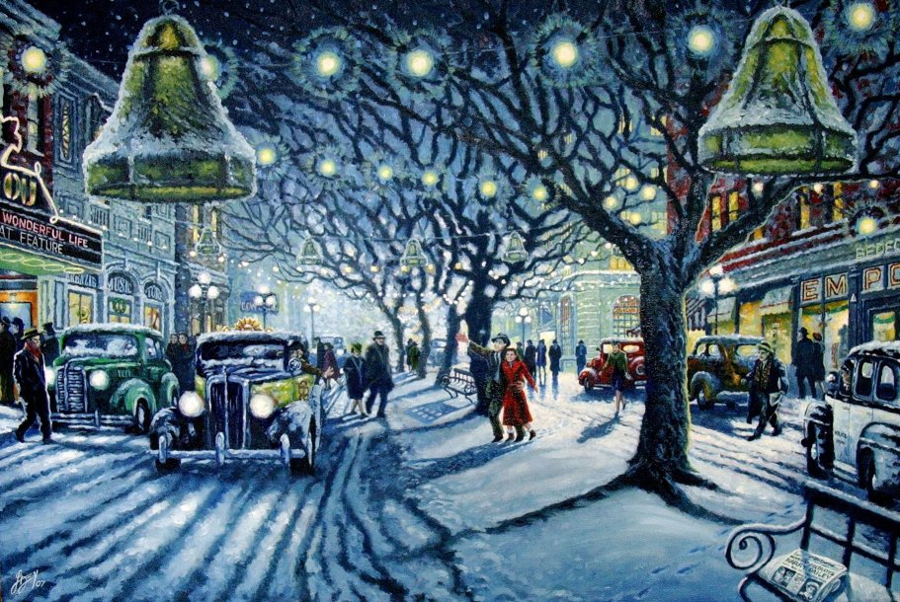 | Example: The soda shop is an interesting place where people can hang out and get a refreshing drink.  ____________________________________________________________  ____________________________________________________________  ____________________________________________________________  ____________________________________________________________  ____________________________________________________________  ____________________________________________________________  ____________________________________________________________  ____________________________________________________________  ____________________________________________________________

↓

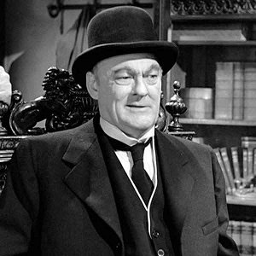 | 4) Who is Mr. Potter? What does he do? What are some of his personality characteristics?  _____________________________________________________________________________________________________  _____________________________________________________________________________________________________  _____________________________________________________________________________________________________
5) a) What is a ‘run on the bank’? b) What happens to the ‘Building and Loan’ when its customers get nervous? c) Why are they nervous?
___________________________________________________________________________________________________________________________
___________________________________________________________________________________________________________________________
___________________________________________________________________________________________________________________________
6) Also with regards to setting, When George is shown as if he never existed the town (Bedford Falls) he used to know and live in no longer exists but is now Pottersville. Describe the setting of Pottersville. How does it contrast with that of Bedford Falls? How do its people seem different??
___________________________________________________________________________________________________________________________
___________________________________________________________________________________________________________________________
___________________________________________________________________________________________________________________________
___________________________________________________________________________________________________________________________

↓

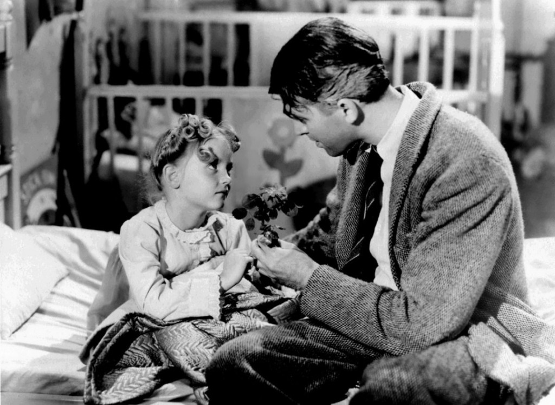 | 7) Another question about symbolism. After George is having a terrible day, he finds out Zuzu is sick with a cold and checks on her. She tells him that the petals from her flower have fallen off and she asks daddy to paste them back on. a) What does George do? b) What do you think the petals may symbolize or represent?  ____________________________________________________________  ____________________________________________________________  ____________________________________________________________  ____________________________________________________________  ____________________________________________________________  ____________________________________________________________
8) How does Clarence – George’s guardian angel – get George to “come around” and not be suicidal anymore?  __________________________________________________________________________________________________  __________________________________________________________________________________________________  __________________________________________________________________________________________________  __________________________________________________________________________________________________  __________________________________________________________________________________________________  __________________________________________________________________________________________________ |  | 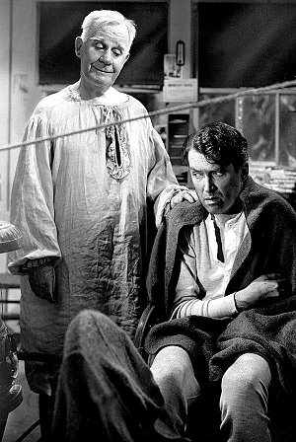
PART 2 - Lessons & Morals
By 'Lessons' I mean: what are the life lessons to be learned from this story? And by 'Morals', I mean what are some good or righteous behaviors that we can learn from the story as they relate to our own lives and society??
1) What life lessons do you think the movie offers us?
2) What morals are presented in the movie's plot? And do you think people from today still follow these morals? Why or why not?
3) Which of these lessons or morals do you believe to be timeless?
4) Family & Community. Have we lost the sense of family & community, or are these still intact and thriving in modern society?
PART 3 – Angels & Guardian Angels
One type of angel - a guardian angel - appears in the movie and is represented by Clarence. Here is some basic information about these followed by some discussion questions:
What are angels?
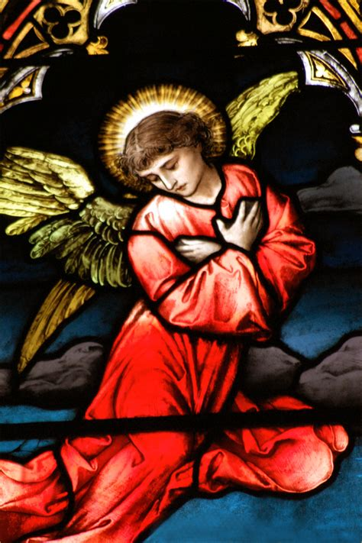 | - An angel is an eternal spirit created by God; it is a celestial or supernatural being that acts as an intermediary between God and humans.  - The word ‘angel’ comes from the Greek word ‘aggelus’ which means ‘messenger’.  - Angels have no physical bodies nor a specific gender, but are often depicted in bodily form with wings.

What are ‘guardian angels’?
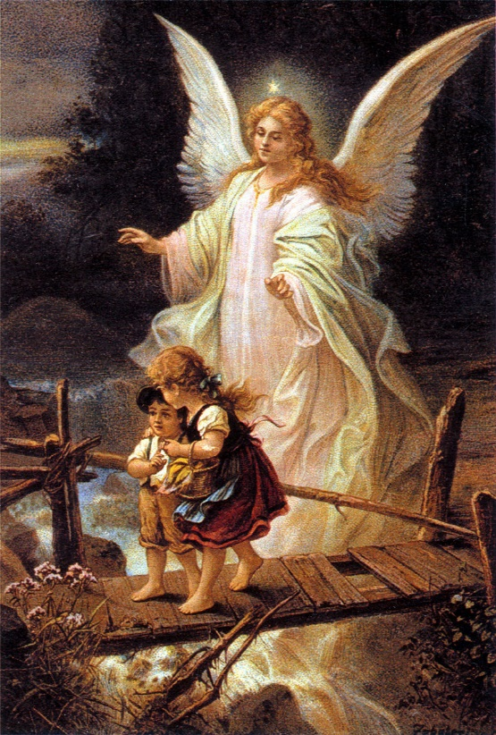 | - A guardian angel is a spirit assigned by God that protects and looks after a specific person throughout their life.  - People may not even be aware that they have a guardian angel, but its invisible force shields them from serious harm, including malevolent (evil) spirits.  Questions:  - Do you think angels are real? Why or why not?  - Do you think you might have your own guardian angel?  - Have you ever been “saved” from a very dangerous situation?  - Can people have a guardian angel even if they don’t believe in God?
PART 4 – Favorite Moments
It's a Wonderful Life has so many interesting and memorable scenes and heartfelt moments.
1. What is your favorite moment or scene in the movie? Why?
___________________________________________________________________________________________________________________________
___________________________________________________________________________________________________________________________
___________________________________________________________________________________________________________________________

