The Great Hill
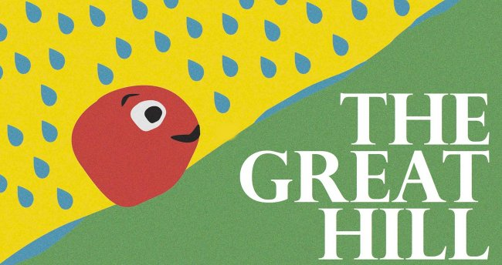
by Daniel Errico

Before time was time, there was a Great Hill.
And on the Great Hill there lived the Yolks.
The Yolks spent their entire lives climbing the Great Hill, trying to reach the top.

Some Yolks climbed fast.
Some Yolks climbed slowly.
One Yolk in particular was a very slow climber. He was different than the rest of the Yolks.

When he climbed, all the other Yolks passed him.
It was hard for him to watch them pass by.
He felt like the worst climber in the world.
Some Yolks made fun of him as they passed.
Others didn’t.

Some Yolks wanted to help him climb but he didn’t let them.

It was hard for him to climb. It was even harder when it rained because the ground got slippery. Sometimes it seemed like it was only raining on him.

But it wasn’t.
There were times when he felt like he wasn’t moving at all.
But he was.

Then one day he met another Yolk who climbed even slower than he did.

He helped the slower Yolk climb.

“Thank You,” said the slower Yolk.
“You’re Welcome,” said the slow Yolk, “I can’t be of much help to anyone else since I climb so slowly.”

“Slowly?” asked the slower Yolk.
“Well yes. I watch other Yolks pass me all the time.”

“I do not know if you are slow or fast, but I do know that you helped me, and that you are still climbing.”
The slow Yolk said goodbye to the slower Yolk, and kept climbing.

“Still climbing,” he thought to himself.
“That is true.”
And he smiled.

So the Yolk kept climbing. He climbed when it was nice out, he climbed when it rained, and he even climbed when it snowed.

As he kept climbing he got better and better.
Sometimes he would pass other Yolks and sometimes they would pass him.
He had stopped paying attention.

He also noticed that some Yolks were no longer climbing.
When a yolk stops climbing it stays where it is.
Some Yolks stop climbing because they are happy with how far they have gone.
Others stop climbing because they don’t want to climb anymore.

The Yolks that had stopped climbing did not like to be passed, and they made it harder to get by.
But the Yolk kept climbing, right over them!

There were still times when the Yolk thought he was climbing an impossible hill, but he kept climbing.

Always, always, climbing.

Do you think he made the top?

THE END

Post-Reading Task
1. Vocabulary
For each bolded word from in the story, write down its Part of Speech (noun, verb, adjective, adverb, preposition, conjunction) and its meaning in the following table. An example is shown.
Word | Part of Speech | Definition / Meaning
climb (climbing)
make fun of (made fun of) | phrasal verb | To laugh at someone.
slippery
impossible

2. Questions about the story
1) Near the beginning of the story it says "Some Yolks made fun of him as they passed."
Has anyone ever made fun of you? What did they do? What did you do?

2) Later in the story it says "He helped the slower Yolk climb."
Did you ever help a classmate or friend that had some difficulty doing something? What did you do?

3) Later on in the story it says "As he kept climbing he got better and better."
What is something you have done more and more and have gotten better at?

4) At the very end of the story it says "Do you think he made it to the top?"
Did he? Does it matter?

