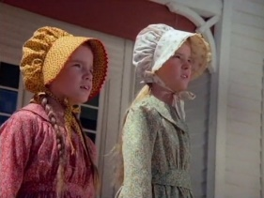
SEASON 1 - Episode 2 - Country Girls
Episode Summary Description: Laura and Mary are nervous about their first day of school in Walnut Grove, but they are quickly put at ease by the genuine kindness of their new teacher and the majority of their classmates. As the girls focus on their studies, Laura clashes with a mean-spirited girl named Nellie Oleson. Later, when their teacher invites the children's families to a special presentation in the classroom, Laura must come up with her own plan of attack when she realizes that she is not prepared. – Source
BEFORE VIEWING...
Have a look at the following questions before you watch the episode. There are spaces provided for you to take notes.
You can either pause the show to take notes, or write them after viewing the episode. Just make sure that your note taking doesn't interrupt your careful watching.
PART 1 - Questions about the story
1) What themes are present in this episode?
___________________________________________________________________________________________________________________________
___________________________________________________________________________________________________________________________
2) What values and beliefs are shown? Give an example.
___________________________________________________________________________________________________________________________
___________________________________________________________________________________________________________________________
3) With regards to setting, what are some interesting things found in the Ingalls home that depict life in those days?
___________________________________________________________________________________________________________________________
___________________________________________________________________________________________________________________________
___________________________________________________________________________________________________________________________
4) Describe both the classroom setting and how classes take place.
___________________________________________________________________________________________________________________________
___________________________________________________________________________________________________________________________
___________________________________________________________________________________________________________________________
5) Describe conflict that happens between two characters. Who are they between? What is the conflict about? How is the conflict handled?
___________________________________________________________________________________________________________________________
___________________________________________________________________________________________________________________________
___________________________________________________________________________________________________________________________
___________________________________________________________________________________________________________________________
6) What does Charles think about Laura's behavior towards Nellie?
___________________________________________________________________________________________________________________________
___________________________________________________________________________________________________________________________
7) What customs and activities are practiced?
Note: a custom is a way of behaving, set of actions, or a belief that has been established for a long time.
___________________________________________________________________________________________________________________________
___________________________________________________________________________________________________________________________
___________________________________________________________________________________________________________________________
___________________________________________________________________________________________________________________________
8) What are the following objects called and used for?
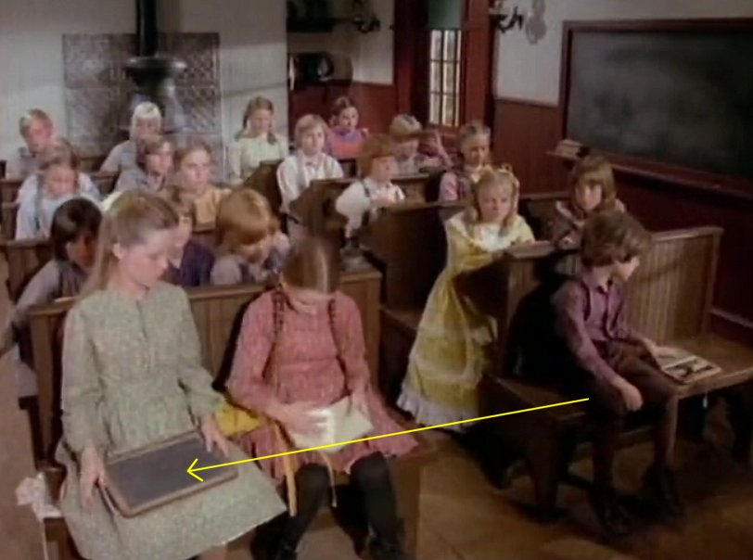 | a) What is it called?  b) What is it used for?
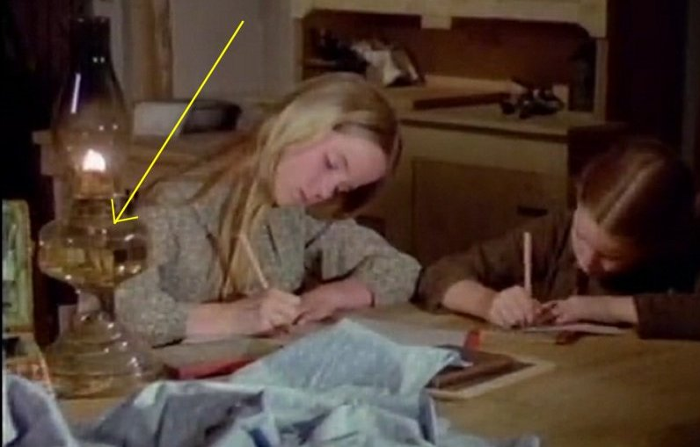 | a) What is it called?  b) What is it used for?  c) How does it work?
PART 2 - Key Lessons from the episode (Discussion)
By 'Key Lessons' I mean: what are the life lessons learned by the characters in the episode?
1) "Do unto others."
a) What does this value mean?

b) Do you think most people follow this today? Why or why not? Can you give some examples?

c) How can it apply to your life? Give an example of how you can treat other people to have them appreciate you more.

2. "Cash on the barrel." (see 17:14 to 19:11)
In Olsen's Mercantile, Laura and Mary are buying two slates for a penny. But Mr. Oleson tells them that they will also need a slate pencil for another penny. The girls have no more money. So, Mr. Oleson tells them: "You just take it along with you anyhow and tell your pa to pay me the next time he comes into town." Laura replies: "No Sir! Cash on the barrel. Pa makes that a strict rule."
a) What does this old expression and belief (Cash on the barrel) mean?

b) Do you always pay "cash in full" (the total amount) for everything you buy? If not, how else do you pay for it?

c) What problems can happen if people do not follow this belief and often buy things "on credit" (which means that they get it now, but can pay for it later)?
PART 3 – Historical Corner
For this part, let's take a step back in time in the nineteenth century American Midwest to explore more about what it was like living then and there.
a) A Country Home
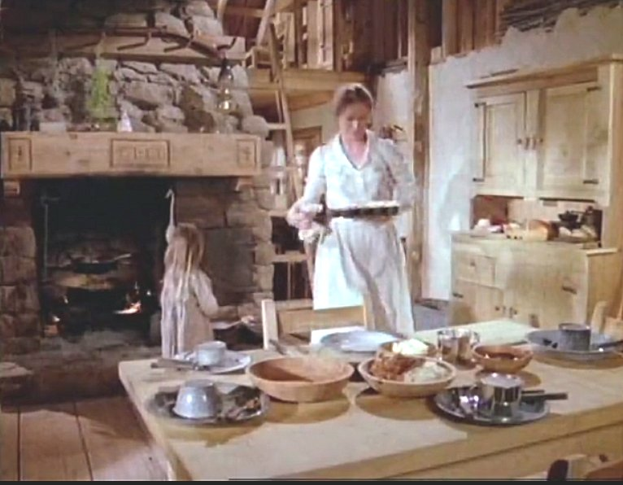

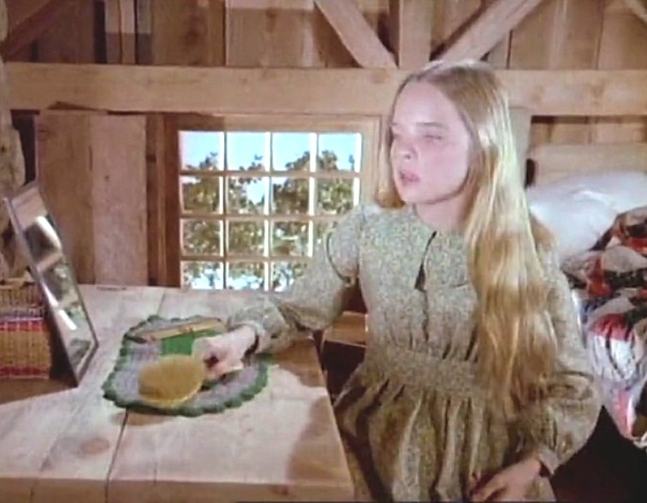
- Observe the images from above and describe what you can find in their 19th century American home.

- State what objects can be seen and what they are used for.

- How would you compare living there compared to your own home?

b) A Country Classroom
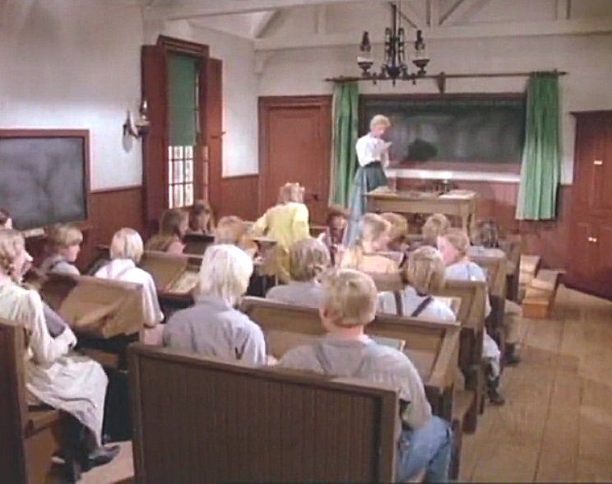
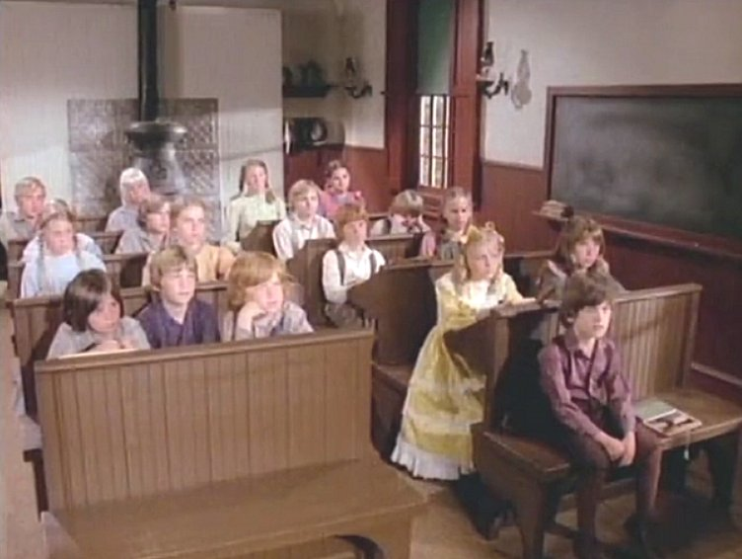 | - What features can be seen in the classroom?  - What is that big thing in the back of the classroom?  - How does it compare to your own school's classroom(s)?  - Does the classroom serve another purpose when school is out?

END OF LESSON SEASON 1 - Episode 2 - Country Girls

BONUS: Also check out our RELATED LESSON from the Who is? / Who was? series entitled Who Was Laura Ingalls Wider? (see http://liberty-academy.org/who-is-was/Laura_Ingalls_Wilder.html)

